Technical Design Document

Project name: Student Result Management

System

Team Name: Technocrats

**Introduction:**

The main objective of the project is to provide the examination result to the student in a simple way. This project is useful for students and institutions for getting the results in simple manner.  
By a result analyser with subject status and marks is an application tool for displaying the results in secure way.

The privileges that are provided to student are to read and execute his/her result by providing user name and password for secure login and in case of new student the registration is available. The architecture implemented is ASP.NET Core

**Functional Requirements:**

The functional requirements of the project are:

**For the Admin:**

* Login
* Update/Delete Admin
* Add/Update/Delete Student
* Add/Update/Delete Branch
* Add/Update/Delete Subjects
* Add/Update/Delete Semester
* Add/Update/Delete Results
* Add/Update/Delete Courses
* View Results
* View Branch
* View Courses
* View Subjects
* View Semester
* View Student
* View Admin

**For the Student:**

* Login
* Search Results
* View Results

**Services**

The different services in which this project is divided into are:

* **Admin Service:** Register a new account for Admin and Student and login (as the admin)
* **Student Service:** login as the student
* **Subject Service**: Adding a new subject, update or delete an existing subject
* **Branch Service:** Adding a new class, update or delete an existing class
* **Semester Service:** Adding a new Semester, update or delete an existing semester
* **Result Service:** Adding a new result, update or delete an existing result, downloading results
* **Courses Service:** Adding a new course, update or delete an existing course
* **Search and View Service:** View student details, view all admin details, view subjects, view results, view class

**Architecture Diagram:**

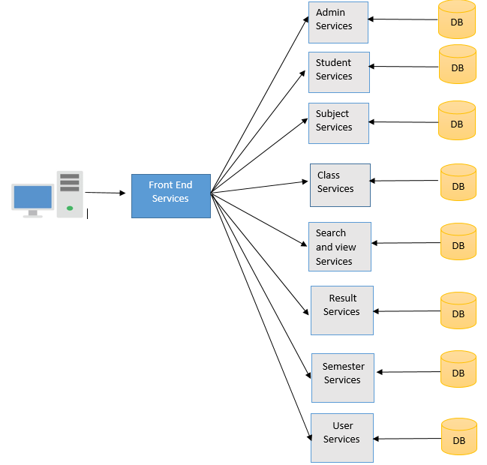

**Entity Relationship Diagram:**

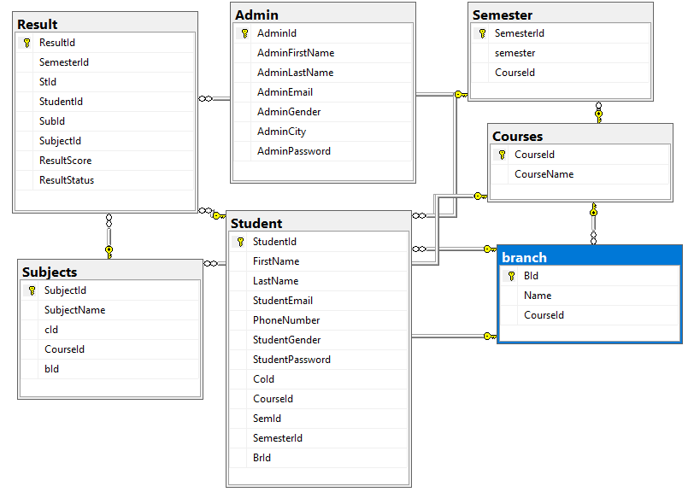

**Sequence Diagrams**

**User Service:**

**Login -**

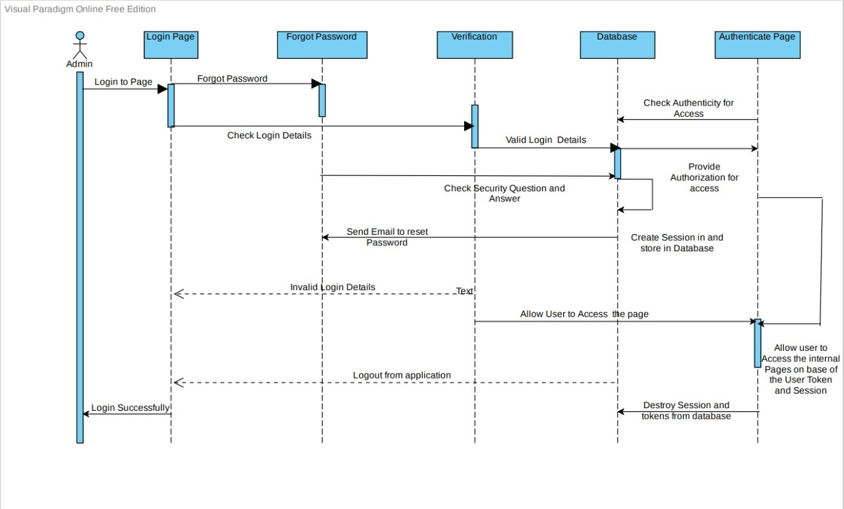

**Registration of new User -**

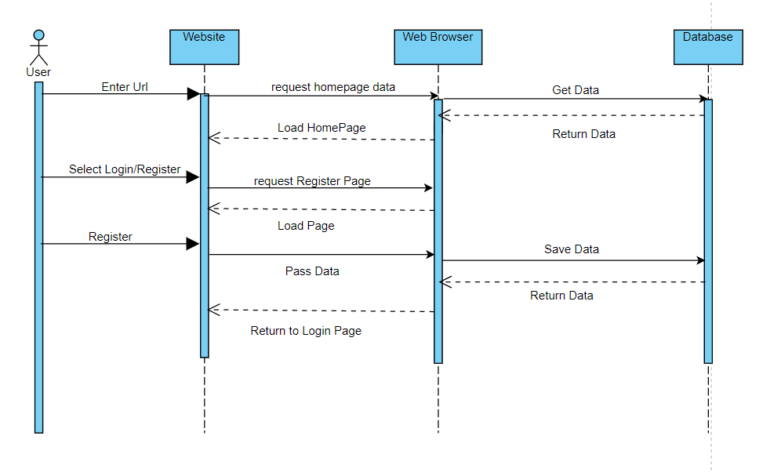

**Logout -**

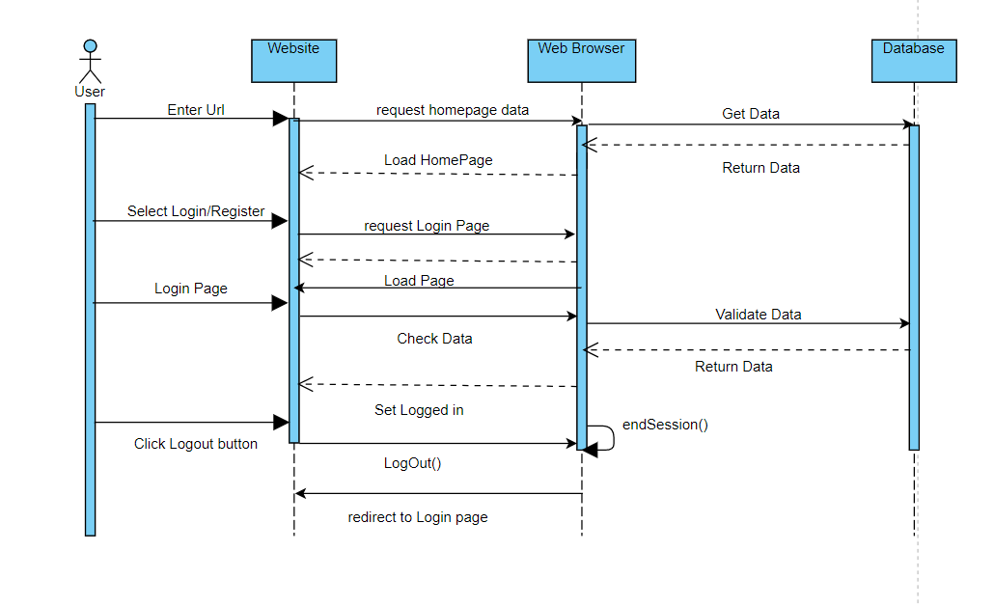

**Subject Service:**

**Insert Subject:**

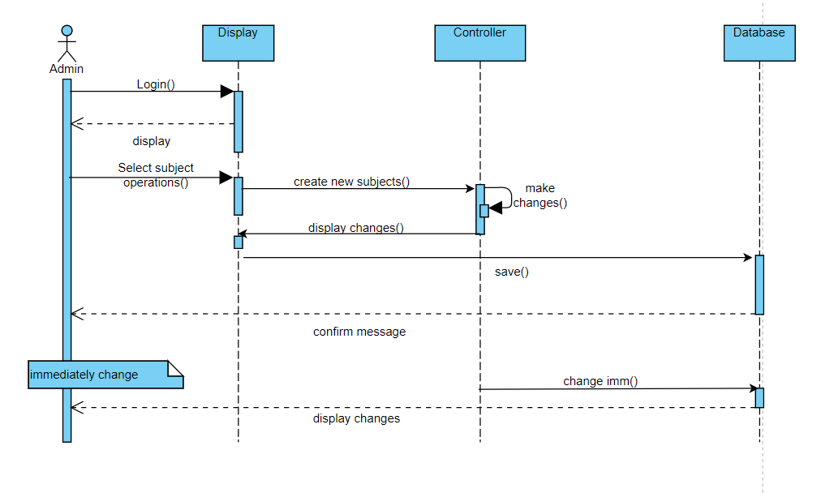

**Update an Existing Subjects:**

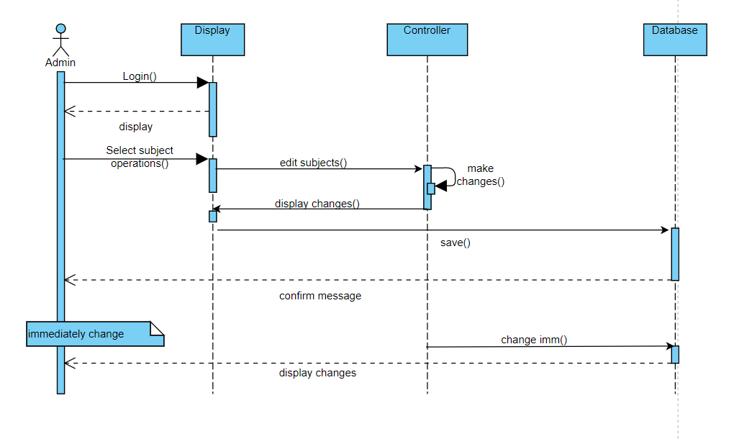

**Delete Subjects:**

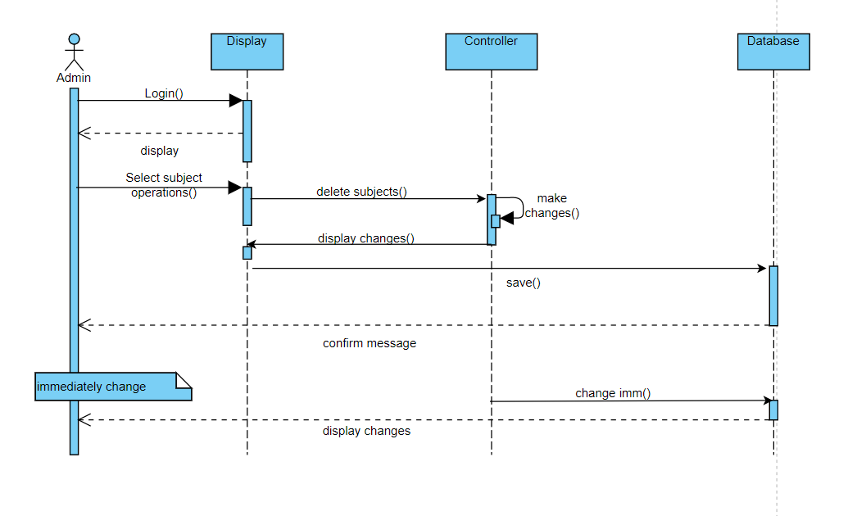

**Sequence Diagram of Student Result Management System:**

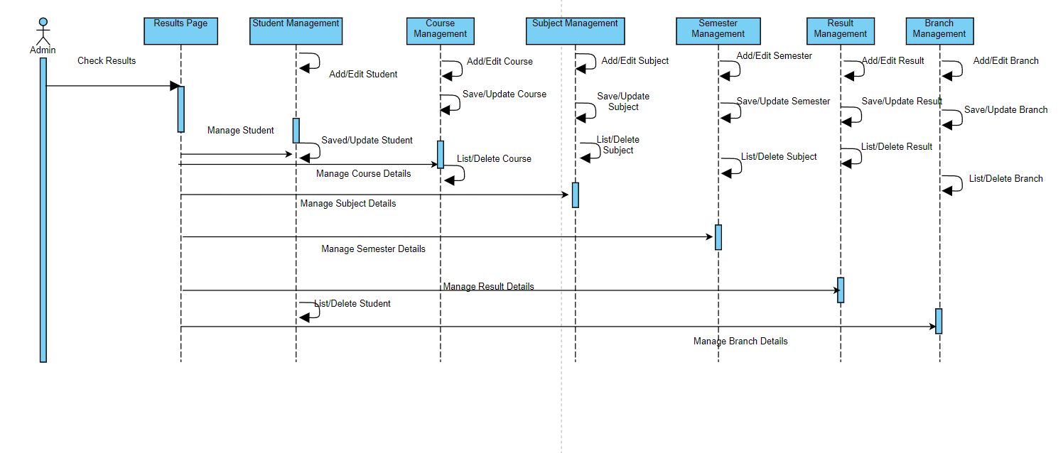

**Class Diagrams**

Student Service:

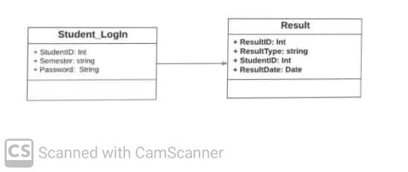

Admin Service:

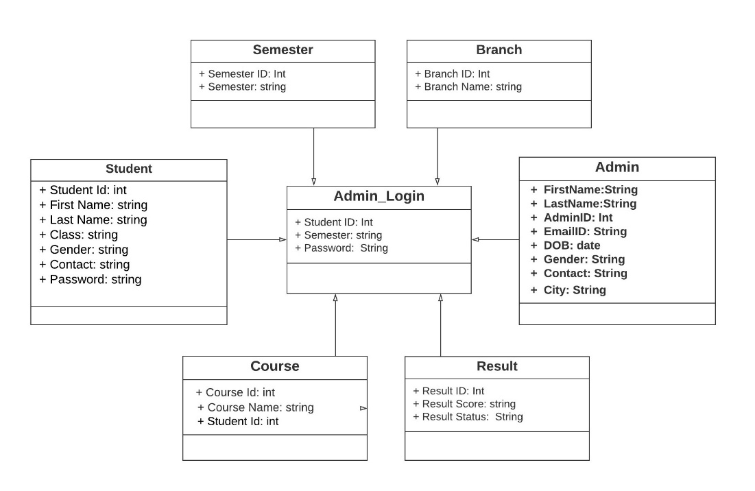

Result Service:

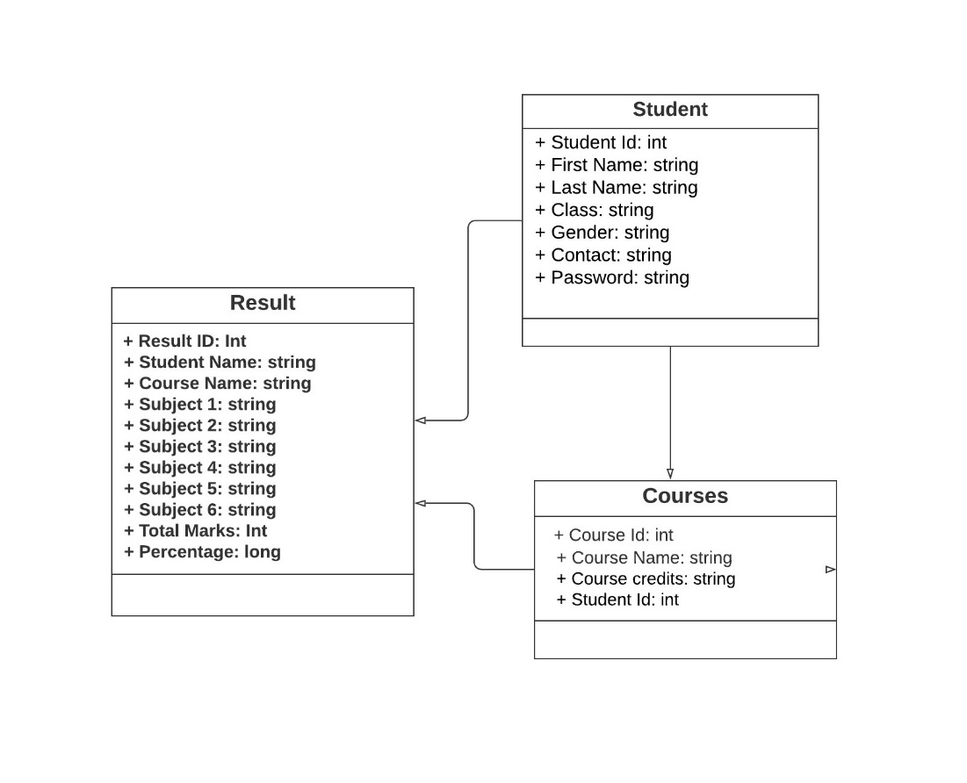

**Activity Diagrams**

Admin Service:

**Login:**

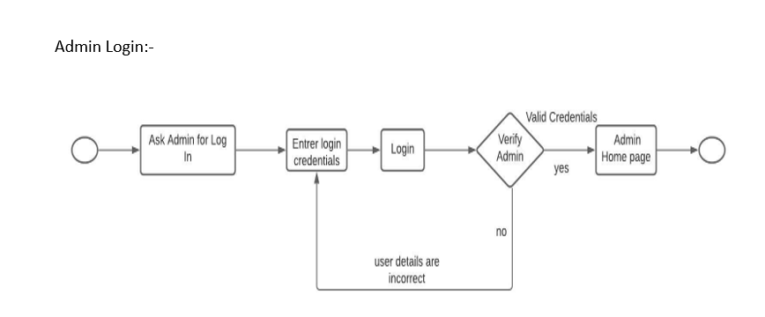

**Admin Registration:**

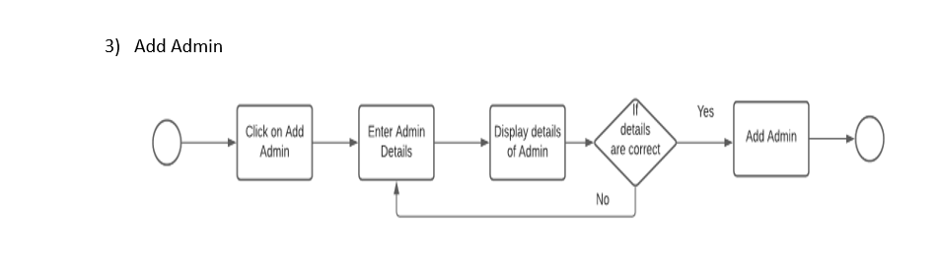

**Student Registration:**

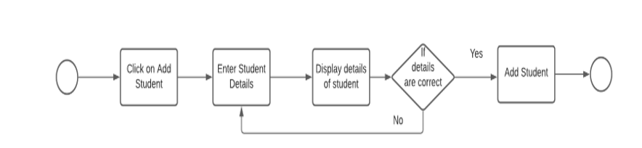

Student Service:

**Login:**

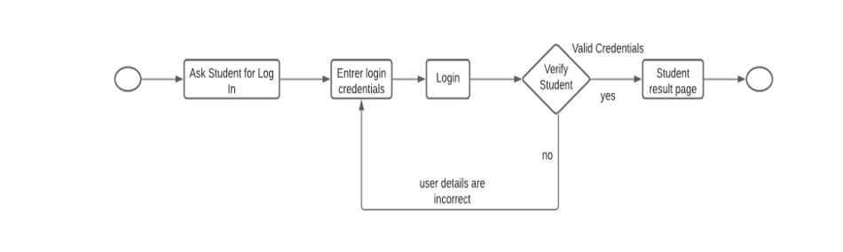

Result Service:

**View Results:**

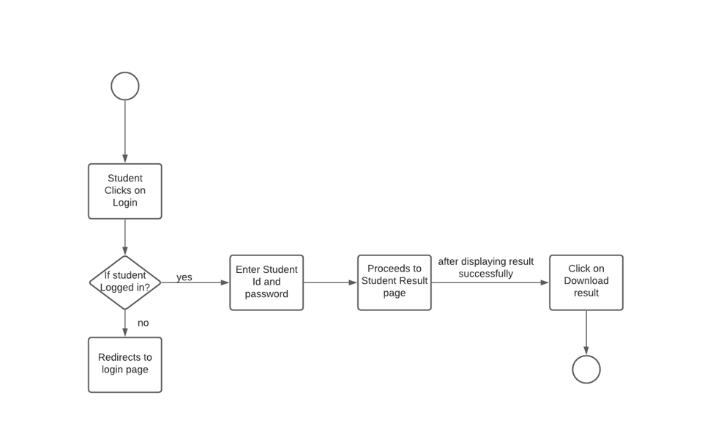

**View Student Details:**

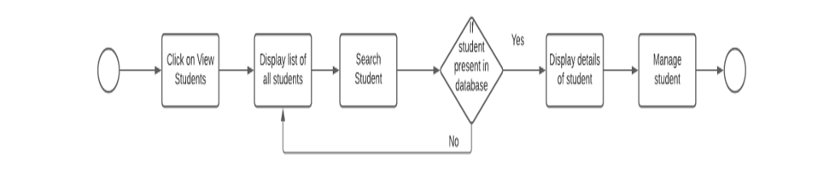

**Wireframes**

Admin Service:

**Admin Login:**

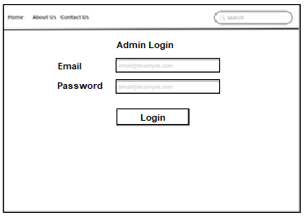

**Student Registration:**

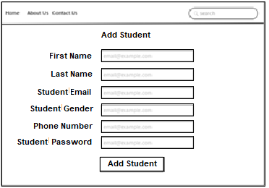

**Admin Registration:**

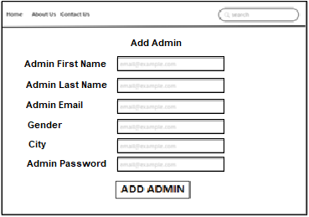

**Add Course:**

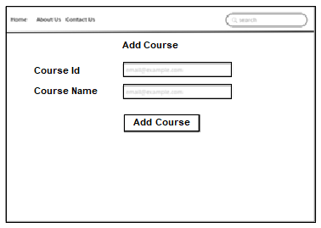

**Add Branch:**

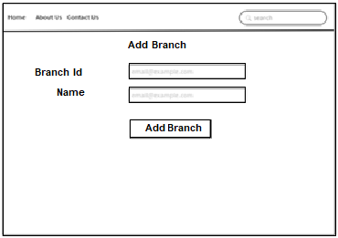

**Add Subject**:

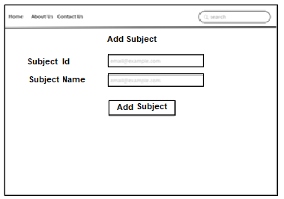

Student Service:

**Login:**

